**Detailed bug report**

**Bug #1 - Malicious script in username not rejected or prevented**

**(related to test case #4)**

**Bug Description:**

The system does not prevent or reject malicious scripts entered in the Username field during the Sign-Up process. This issue creates a serious security vulnerability, as it may allow Cross-Site Scripting (XSS) attacks, enabling attackers to execute scripts on the website.

**Severity:** Critical

**Test environment:** Windows(64-bit)**,** Chrome Version 134.0.6998.89

**Pre-condition:**

The web site is up and running.

**Steps to reproduce:**

1. Open the website: https://www.demoblaze.com/index.html.
2. Click on the **Sign up** button.
3. Fill in **Username** field malicious script like
4. Fill in **Password** field with password.
5. Click **Sign up** button.

**Expected results:**

1. The user is **not** successfully registered.
2. Error message is displayed.

**Actual results:**

A successfully signed-up message is displayed, indicating that the user has been successfully registered, even though a malicious script was entered in the username field.

**Bug #2 - Sending message is possible without email address**

**(related to test case #3)**

**Bug Description:**

The system allows users to send a message via the Contact Us form without providing an email address. This issue can result in missing contact details, making it impossible to respond to users.

**Severity:** High

**Test environment:** Windows(64-bit)**,** Chrome Version 134.0.6998.89

**Pre-condition:**

The web site is up and running.

**Steps to reproduce:**

1. Open https://www.demoblaze.com/index.html in a web browser and Click on the **Home** button.
2. Click on the **Contact** button.
3. Leave the **Contact Email** field empty.
4. Click on **Send message** button.

**Expected results:**

1. Error message is displayed indicating that the **Contact Email** field is required.
2. **Send Message** button should be disabled**.**

**Actual results:**

1. A confirmation message appears, indicating that the message was successfully sent, even though the **Contact Email field** was left empty.
2. **Send Message** button is enabled and clickable**.**

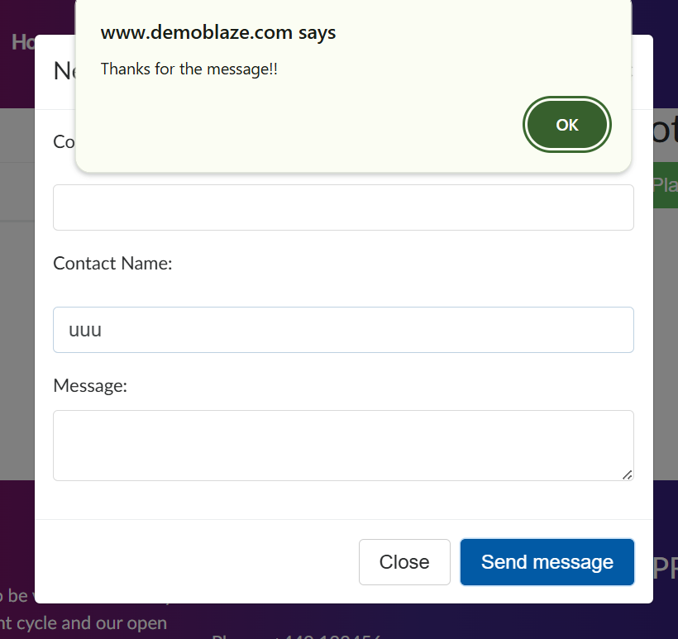

**Bug #3 - Can place order without products in the Cart (related to test case #5)**

**Bug Description:**

The system allows users to place an order without adding any products to the cart. This issue may lead to invalid orders, potential financial discrepancies, and a poor user experience.

**Severity:** Critical

**Test environment:** Windows(64-bit)**,** Chrome Version 134.0.6998.89

**Pre-condition:**

The web site is up and running.

There are no products on Cart.

**Steps to reproduce:**

1. Open https://www.demoblaze.com/index.html in a web browser and Click on the Cart button.
2. Click on the **Place Order.**

**Expected results:**

The **Place Order** button should be disabled and not be clickable.

The **Place Order** button should not trigger any action if clicked.

If the user attempts to check out with an empty cart, an error message should appear.

**Actual results:**

The **Place Order** button is enabled and clickable.

The user can complete the order without adding any products.

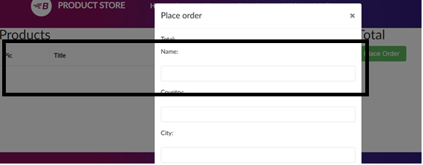

**Bug #4 - Previous button on the first page navigates to a different section**

**Bug Description:**

The **Previous** button is visible on the first page and incorrectly navigates to a different section instead of being disabled or hidden. This behaviour causes unexpected navigation, leading to confusion and poor user experience.

**Severity:** Medium

**Test environment:** Windows(64-bit)**,** Chrome Version 134.0.6998.89

**Pre-condition:**

The web site is up and running.

There are products on the list.

**Steps to reproduce:**

1. Open https://www.demoblaze.com/index.html in a web browser and Click on the **Home** button.
2. Click on the **Monitors** button.
3. Click on the **Previous** button**.**

**Expected results:**

**Previous** button should not be on the first page or if exist should be disabled.

**Actual results:**

The **Previous** button incorrectly navigates to another section instead of remaining on the same page or being disabled.

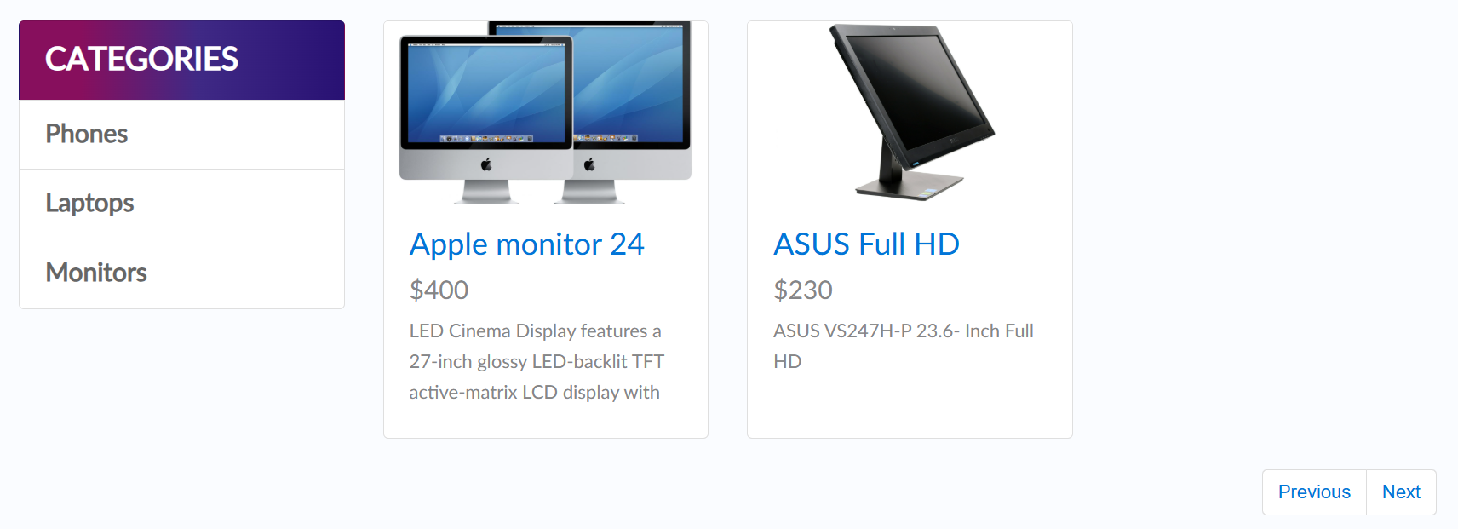

**Bug #5 - Inconsistent header bar alignment**

**Bug Description:**

The header bar (top navigation menu) is not consistently aligned across different pages. This inconsistency affects the visual structure of the application and can cause user confusion or a disjointed experience.

**Severity:** Low - Medium

**Test environment:** Windows(64-bit)**,** Chrome Version 134.0.6998.89

**Pre-condition:**

The web site is up and running.

There are products on the list.

**Steps to reproduce:**

1. Open https://www.demoblaze.com/index.html in a web.
2. Observe the positioning of the **header bar** on each page.

**Expected results:**

The header bar should maintain a **consistent position** across all pages.

**Actual results:**

The header bar position is not uniform across different pages.

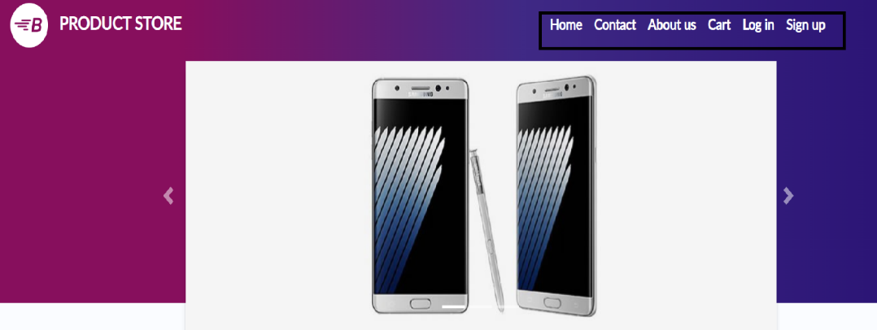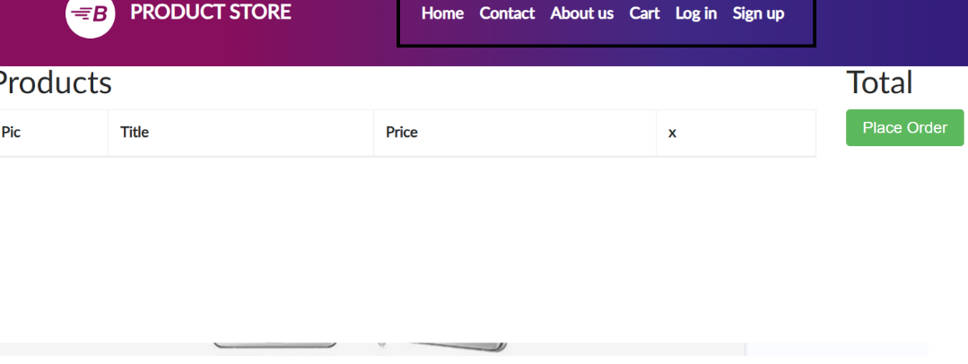

**Bug #6 – Purchase Button Remains Active After Order Creation**

**Bug Description:**

After successfully creating an order, the **Purchase** button remains active, allowing the user to click it multiple times and generate multiple orders with different order numbers, which is unintended.

**Severity:** High

**Test environment:** Windows(64-bit)**,** Chrome Version 134.0.6998.89

**Pre-condition:**

The web site is up and running.

There are products on the list.

**Steps to reproduce:**

1. Open https://www.demoblaze.com/index.html in a web browser and Click on the **Home** button.
2. Click on the **Phones** button.
3. Click on the name of selected Phone from the list.
4. Click on the **Add to Cart** button.
5. Click **Ok** button in the popup.
6. Navigate to **Cart** page.
7. Click on the **Place Order.**
8. Fill all fields correctly and click on **Purchase** button.

**Expected results:**

After an order is successfully created, the **Purchase** button should be disabled, or the user should be redirected to a confirmation page to prevent duplicate orders.

**Actual results:**

The **Purchase** button remains active, allowing multiple clicks and generating multiple orders with different order numbers.

